Circuit Analysis (Lab10)

Experiment 9: Verification of Thevenin’s Theorem

Name: Noor-Ul-Ain Registration No: 2025-CE-83 Date: ……………………………. Grade and Signature: ……………………
CLO2 CLO3 | Use with identification the circuit components, breadboards, multimeter, power supplies, signal generators, and oscilloscopes. Make measurements in their own constructed electric circuits.
Psychomotor/Affective | Level1  (1) | Level2 (2-3) | Level3 (4-5) | Level4 (6-7)
Report Marks (3)
 | Total marks (10)

Objective
The objective of this lab is verify Thevenin’s theorem and to find the full load current.

Apparatus Required
Sr. no | Apparatus | Range | Quantity
1 | Regulated Power Supply | Standard | 1
2 | Signal Generator | Standard | 1
3 | Oscilloscope | Standard | 1
4 | Digital Multimeter | Standard | 1
5 | Breadboard & Wires | Standard | As Required
6 | Resistors | 1k, 330 ohms | 1,3
7 | Potentiometer | Standard | 1

Description

Statement:
Any linear bilateral, active two terminal network can be replaced by an equivalent voltage source (VTH). Thevenin’s voltage or V OC in series with looking pack resistance RTH.

Precautions:
- Voltage control knob of RPS should be kept at minimum position.
- Current control knob of RPS should be kept at maximum position

Procedure:
- Connections are given as per the circuit diagram.
- Set a particular value of voltage using RPS and note down the corresponding ammeter readings. To find VTH 3. Remove the load resistance and measure the open circuit voltage using multimeter (VTH). To find RTH
- To find the Thevenin’s resistance, remove the RPS and short circuit it and find the RTH using multimeter.
- Give the connections for equivalent circuit and set VTH and RTH and note the corresponding ammeter reading. 6. Verify Thevenins theorem.

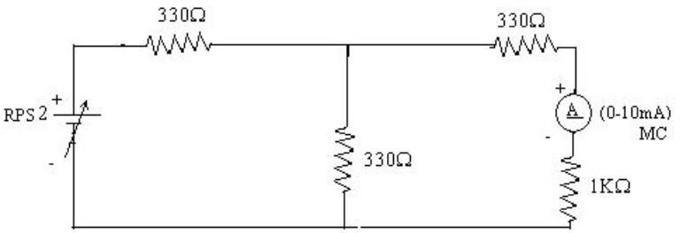
Circuit - 1: To find load current

To find VTH
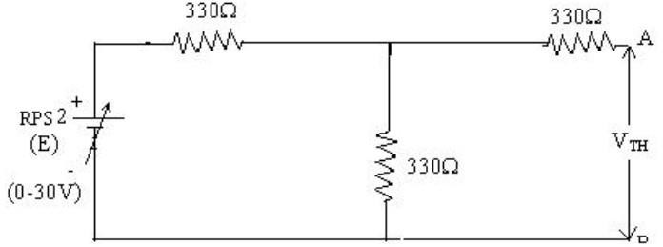

To find RTH
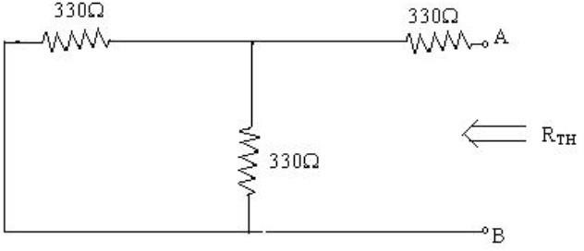

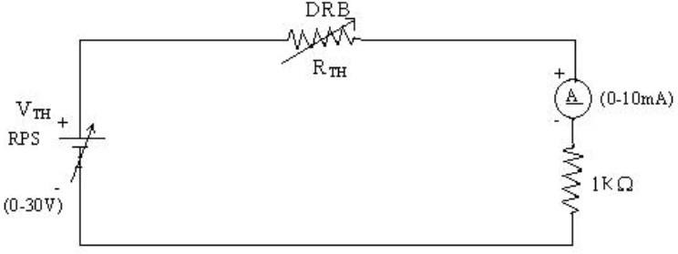
Thevenin’s Equivalent circuit:

Thevenin Practical Values

 | E(V) | VTH(V) | RTH(ohms) | IL (mA)
 |  |  |  | Circuit - I | Equivalent Circuit
Values | 10V | 5V | 495 | 3.34 | 3.34

Post Lab Questions

1. What is Thevenin's theorem?
Thevenin's theorem states that any linear bilateral two-terminal electrical network containing voltage sources, current sources, and resistors can be replaced by an equivalent circuit consisting of a single voltage source (V_{TH}) in series with a resistance (R_{TH}).
The Thevenin voltage (V_{TH}) is the open-circuit voltage across the output terminals, while Thevenin resistance (R_{TH}) is the equivalent resistance measured from the terminals after removing independent sources.
This theorem simplifies complex circuits and makes analysis of load current and voltage easier.

2. What are the applications of Thevenin's theorem?
Applications of Thevenin's theorem are:
- It simplifies complex electrical circuits into simple equivalent circuits.
- It is used to calculate load current and load voltage easily.
- It helps in analyzing power systems and electronic circuits.
- It is widely used in circuit troubleshooting and design.
- It is useful for studying the effect of changing load resistance.
- It reduces mathematical calculations in network analysis.
- It is used in communication, instrumentation, and control systems.

3. What are the theoretical and practical limitations of Thevenin's theorem?

Theoretical Limitations:
- The theorem is applicable only to linear and bilateral circuits.
- It cannot be directly applied to non-linear components like diodes and transistors.
- It is mainly used for two-terminal networks only.
- It does not directly analyze transient or time-varying circuits without modifications.

Practical Limitations:
- Measuring (R_{TH}) practically may introduce errors because of instrument tolerances.
- Internal resistance of measuring devices affects accuracy.
- Wire resistance and loose connections may change practical readings.
- Power losses and temperature variations can affect resistor values.
- Practical results may slightly differ from theoretical calculations because of component tolerances.

Explanation of the Circuits

1. Original Circuit
The original circuit is used to measure the load current flowing through the load resistor. The voltage source supplies power to the circuit, and the current passes through the first resistor before reaching a junction where it divides into two paths. One path goes directly to ground through a resistor, while the other path passes through another resistor, the ammeter, and the load resistor. The ammeter measures the load current. This circuit represents the complete practical network before applying Thevenin’s theorem.

2. Circuit for Finding Thevenin Voltage
In this circuit, the load resistor and the ammeter are removed from the network. Removing the load creates an open circuit at the output terminals. Since no current flows through the open branch, the output voltage measured across the terminals becomes the Thevenin voltage. The circuit behaves like a simple voltage divider, and the measured voltage is called the open-circuit voltage or Thevenin voltage.

3. Circuit for Finding Thevenin Resistance
To determine the Thevenin resistance, the independent voltage source is turned off and replaced with a short circuit. After this change, the resistors in the circuit combine into an equivalent resistance as viewed from the output terminals. This equivalent resistance is called the Thevenin resistance. It represents the internal resistance of the original network seen by the load resistor.

4. Thevenin Equivalent Circuit
The Thevenin equivalent circuit is the simplified form of the original complex circuit. The entire network is replaced by a single voltage source in series with a single resistor. The load resistor is then connected to this simplified circuit. When the load current is measured again, it is almost the same as the current obtained from the original circuit. This proves that the original network and the Thevenin equivalent circuit behave the same from the load’s point of view and verifies Thevenin's theorem.

Circuits
